**Buenos Aires and Toronto neighborhoods comparison**

Leonardo Chung

December, 2020

## Introduction

### Background

Buenos Aires and Toronto are very diverse cities and are the financial capitals of their respective countries. The kind of activities that each city offers is an important factor for tourists planning to visit them or for people who will or want to move to these cities.

### Problem

Data about the venues available in each neighborhood can give as un idea about the characteristics of each city and the neighborhoods where we should go if we would like to visit a certain type of venues.

### Interest

People who will visit any of these cities may be interested in the results found in this project, and also people who are planning to move to these multicultural cities.

## Data acquisition

### Data sources

Data about neighborhoods in Buenos Aires will be gathered from the city government´s webpage. For the Toronto ones, data will be gathered from the Wikipedia page.

The data about venues from both cities is available in Foursquare. They will be gathered for each neighborhood with a radius of 1000 meters, and a limit of 100 total venues for each one.

## Data analysis

### Visualization of neighborhoods

First, through the *geocorders* package, we will get the longitude and latitude values of each neighborhood, and then we will plot a map using the *folium* package to see their distribution.

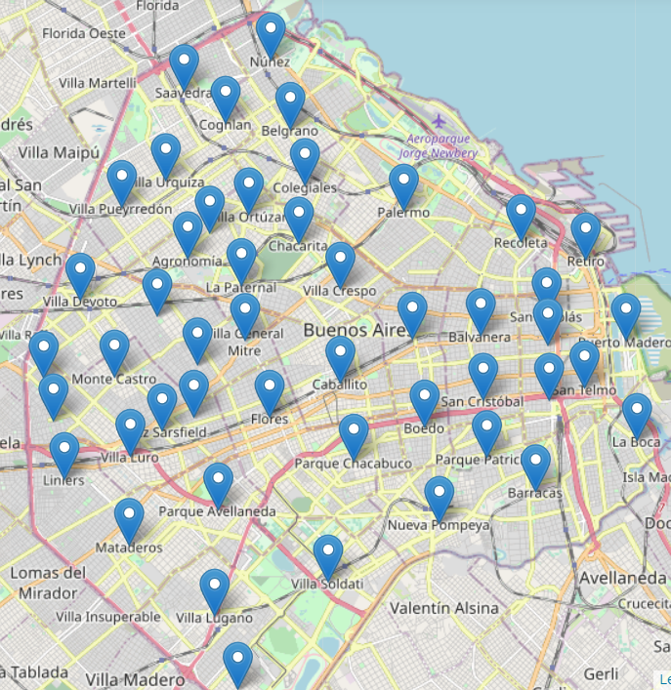

Figure . Buenos Aires neighborhoods.

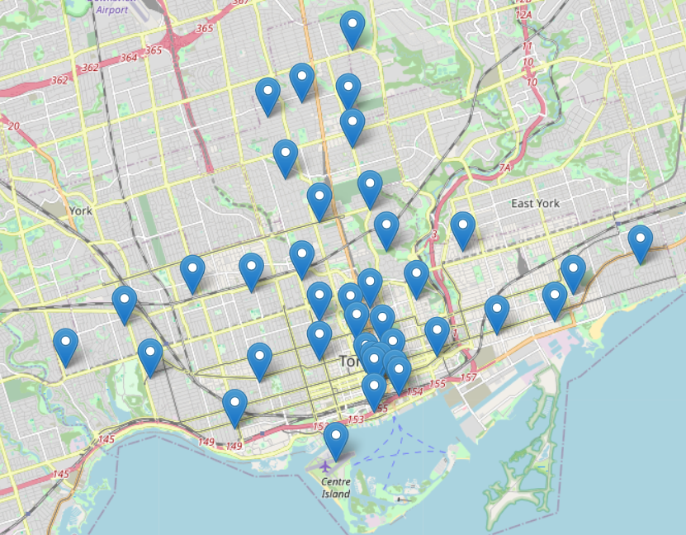

Figure 2. Toronto neighborhoods.

## Neighborhoods clustering

We will use the k-means clustering method to group similar neighborhoods and see if the activities of both cities are similar.

First, we use the Elbow Method to calculate the optimal k for each city.

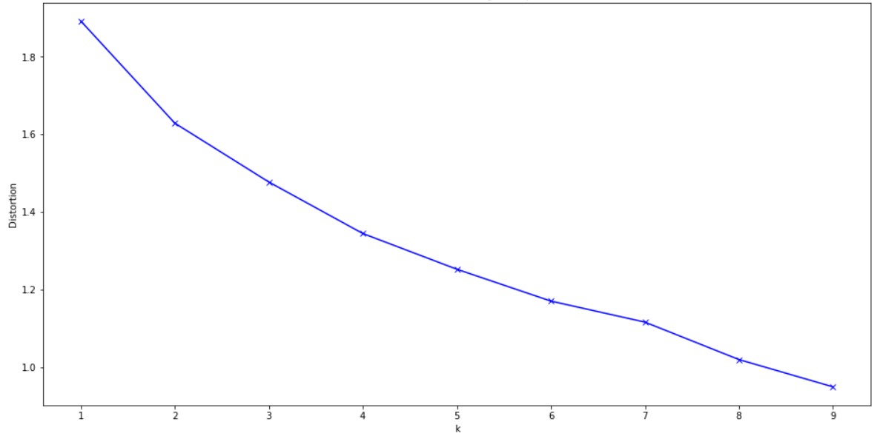

Figure 3. Buenos Aires Elbow method.

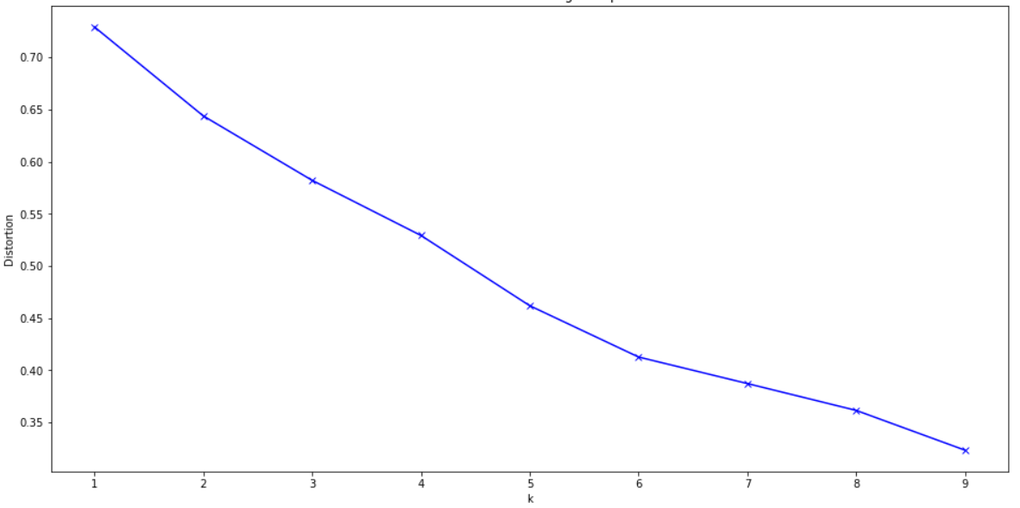

Figure 4. Toronto Elbow method.

We see that, for Buenos Aires, from k = 6 the distortion reduction is considerably low, and for Toronto, from k = 5 the reduction is low. So, we will take those values for the k-means clustering.

After we apply the model, we plot the resulting clusters in the map.

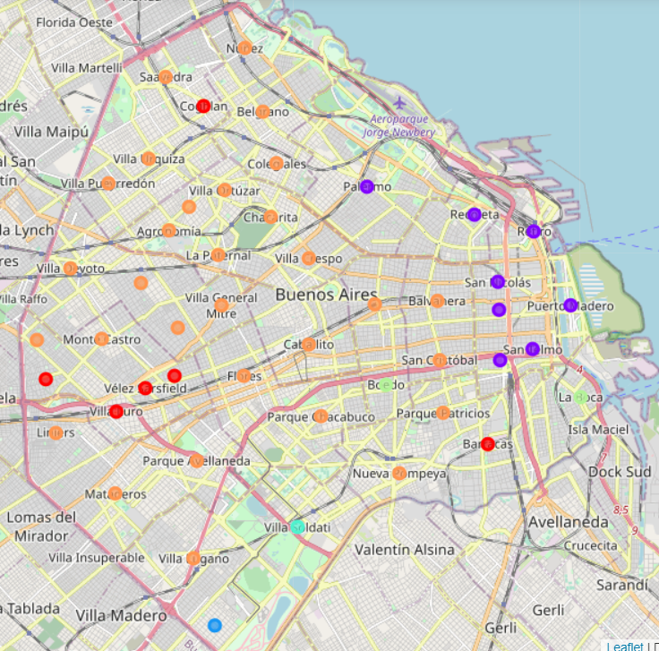

Figure 5. Buenos Aires neighborhoods clustering.

Cluster 1 (red) – Pizza places.

Cluster 2 (purple) – Latin restaurants and hotels.

Cluster 3 (light blue) – Racetracks.

Cluster 4 (aqua green) – Moving target.

Cluster 5 (light green) – Argentinian restaurants.

Cluster 6 (orange) – Snacks (coffee shops, ice cream shops, bars.

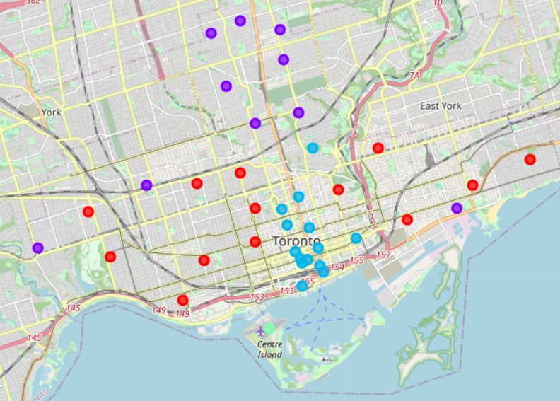

Figure 6. Toronto neighborhoods clustering.

Cluster 1 (red) – Bars, coffee shops and restaurants.

Cluster 2 (purple) – Parks, restaurants and coffee shops.

Cluster 3 (light blue) – Coffee shops and Japanese restaurants.

Cluster 4 (light green) – Center Island (harbor).

Cluster 5 (aqua green) – Bookstores.

## Conclusions

We see that Buenos Aires has a more diverse kind of activities, and the neighborhoods are not very similar. We also have various kinds of cuisine, such as Argentinian, Spanish or Italian restaurants.

In Toronto, the popularity of coffee shops is huge, since almost every neighborhood has lots of it. We would not have to move much to drink a coffee. Also, the cuisine is not very diverse, since the most popular ones are the Japanese ones which offer sushi.

From the obtained results, we can conclude that if you are an avid coffee drinker, you should pay Toronto a visit, since the huge offer of coffee shops implies that you can taste a great variety of coffee flavours and styles. Japanese restaurants are also popular there, so if you are into Asian food you will enjoy Toronto.

If you prefer variety and more diverse activities, you must go to Buenos Aires. You can find great pizza places, taste the popular ***asado*** in an Argentinian restaurant, and choose from the many coffee shops that the city can offer. Also, as the number of hotels is high, you will not have a hard time looking for a place to sleep, even if it is peak season.